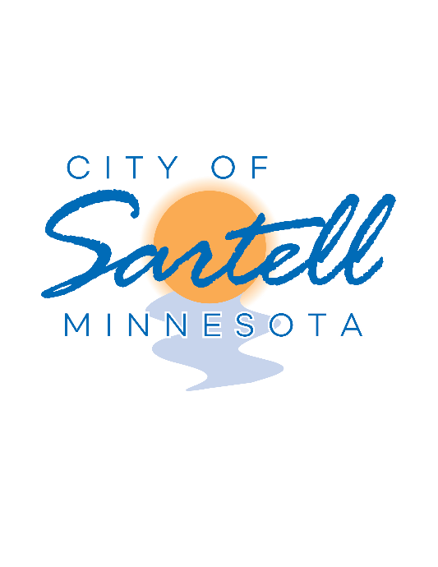

Job Advertisement
Fire Chief

City of Sartell

The City of Sartell is seeking outstanding candidates for a full-time Fire Chief. This position will perform complex professional work planning, organizing, and administering daily fire operations; scheduling and assigning personnel and equipment; preparing and presenting directives and reports; developing training programs, fire inspections, fire prevention, fire suppression, emergency medical services, fire education, technical work, and related work as apparent or assigned.

Starting salary range: $89,175 - $115,177 DOQ

All candidates must complete a City of Sartell employment application packet, which can be found online at www.sartellmn.com. Applications can be submitted to City Administrator Anna Gruber via email anna.gruber@sartellmn.com.

Application Deadline: February 3rd, 2021 by 1:00 P.M. First-round interviews will be held the week of February 8th – 12th, 2021.

AA/EEO EMPLOYER

